NAME: M.SHEELA REG NO: 192521221
COURSE NAME: JAVA PROGRAMMING COURSE CODE: CSA0924

1).Read three subject marks and determine whether the student has
passed all subjects. Also display Distinction when the average is at
least 75
AIM
To read three subject marks, determine whether the student has passed all subjects, and display "Distinction" if the average is 75 or above.
Pseudocode
START
Read mark1, mark2, mark3

average = (mark1 + mark2 + mark3) / 3

IF (mark1 >= 40 AND mark2 >= 40 AND mark3 >= 40) THEN
Display "Student Passed"

IF (average >= 75) THEN
Display "Distinction"
ENDIF

ELSE
Display "Student Failed"
ENDIF

STOP
C Program
#include <stdio.h>

int main()
{
int mark1, mark2, mark3;
float average;

printf("Enter three subject marks: ");
scanf("%d %d %d", &mark1, &mark2, &mark3);

average = (mark1 + mark2 + mark3) / 3.0;

if (mark1 >= 40 && mark2 >= 40 && mark3 >= 40)
{
printf("Student Passed\n");

if (average >= 75)
{
printf("Distinction\n");
}
}
else
{
printf("Student Failed\n");
}

return 0;
}
flo

╭──────────────╮
( START )
╰──────┬───────╯
│
▼
╭───────────────────────╮
╱ Read M1, M2 and M3 ╲
╲ Marks ╱
╰──────────┬────────────╯
│
▼
┌────────────────────────┐
│ Average=(M1+M2+M3)/3 │
└──────────┬─────────────┘
│
▼
╭───────────────╮
◇ All Marks ≥50? ◇
╰───┬───────┬───╯
Yes No
│ │
▼ ▼
┌─────────────┐ ┌─────────────┐
│ Display PASS│ │Display FAIL │
└──────┬──────┘ └──────┬──────┘
│ │
▼ │
╭───────────────╮ │
◇ Average ≥75 ? ◇ │
╰───┬───────┬───╯ │
Yes No │
│ │ │
▼ ▼ │
┌────────────────────┐ │
│Display DISTINCTION │ │
└─────────┬──────────┘ │
│ │
└────────┬───────┘
▼
╭──────────────╮
( END )
╰──────────────╯

AIM
To read N integers into an array and find the longest consecutive run of equal values.
Pseudocode
START

Read N
Read array A[0...N-1]

maxCount = 1
currentCount = 1
value = A[0]

FOR i = 1 TO N-1
IF A[i] == A[i-1] THEN
currentCount = currentCount + 1
ELSE
currentCount = 1
ENDIF

IF currentCount > maxCount THEN
maxCount = currentCount
value = A[i]
ENDIF
ENDFOR

Display "Longest consecutive value =", value
Display "Length of run =", maxCount

STOP
Algorithm
Start.
Read the value of N.
Read N integers into the array.
Initialize:
maxCount = 1
currentCount = 1
value = first array element
Compare each element with the previous element.
If both are equal, increase currentCount.
Otherwise, reset currentCount to 1.
If currentCount > maxCount, update maxCount and store the value.
Display the longest consecutive value and its length.
Stop.
C Program
#include <stdio.h>

int main()
{
int n, i;
int a[100];
int currentCount = 1, maxCount = 1;
int value;

printf("Enter the number of elements: ");
scanf("%d", &n);

printf("Enter the elements:\n");
for(i = 0; i < n; i++)
{
scanf("%d", &a[i]);
}

value = a[0];

for(i = 1; i < n; i++)
{
if(a[i] == a[i - 1])
{
currentCount++;
}
else
{
currentCount = 1;
}

if(currentCount > maxCount)
{
maxCount = currentCount;
value = a[i];
}
}

printf("Longest consecutive value = %d\n", value);
printf("Length of run = %d\n", maxCount);

return 0;
}
Example
Input:
Enter N = 10
1 1 2 2 2 3 3 3 3 4
Output:
Longest consecutive value = 3
Length of run = 4 AIM
To read N integers into an array and find the longest consecutive run of equal values.
Pseudocode
START

Read N
Read array A[0...N-1]

maxCount = 1
currentCount = 1
value = A[0]

FOR i = 1 TO N-1
IF A[i] == A[i-1] THEN
currentCount = currentCount + 1
ELSE
currentCount = 1
ENDIF

IF currentCount > maxCount THEN
maxCount = currentCount
value = A[i]
ENDIF
ENDFOR

Display "Longest consecutive value =", value
Display "Length of run =", maxCount

STOP
Algorithm
Start.
Read the value of N.
Read N integers into the array.
Initialize:
maxCount = 1
currentCount = 1
value = first array element
Compare each element with the previous element.
If both are equal, increase currentCount.
Otherwise, reset currentCount to 1.
If currentCount > maxCount, update maxCount and store the value.
Display the longest consecutive value and its length.
Stop.
C Program
#include <stdio.h>

int main()
{
int n, i;
int a[100];
int currentCount = 1, maxCount = 1;
int value;

printf("Enter the number of elements: ");
scanf("%d", &n);

printf("Enter the elements:\n");
for(i = 0; i < n; i++)
{
scanf("%d", &a[i]);
}

value = a[0];

for(i = 1; i < n; i++)
{
if(a[i] == a[i - 1])
{
currentCount++;
}
else
{
currentCount = 1;
}

if(currentCount > maxCount)
{
maxCount = currentCount;
value = a[i];
}
}

printf("Longest consecutive value = %d\n", value);
printf("Length of run = %d\n", maxCount);

return 0;
}
Example
Input:
Enter N = 10
1 1 2 2 2 3 3 3 3 4
Output:
Longest consecutive value = 3
Length of run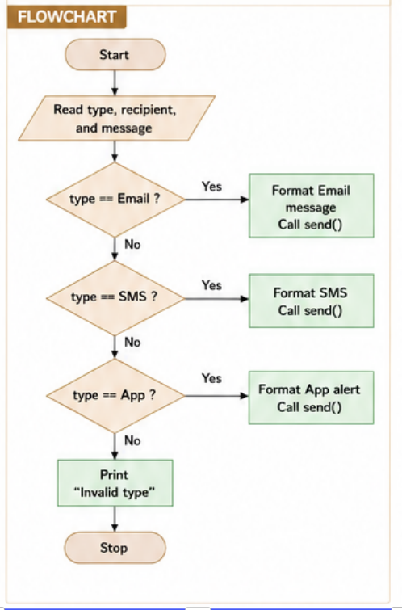

AIM
To read N integers into an array and find the longest consecutive run of equal values.
Pseudocode
START

Read N
Read array A[0...N-1]

maxCount = 1
currentCount = 1
value = A[0]

FOR i = 1 TO N-1
IF A[i] == A[i-1] THEN
currentCount = currentCount + 1
ELSE
currentCount = 1
ENDIF

IF currentCount > maxCount THEN
maxCount = currentCount
value = A[i]
ENDIF
ENDFOR

Display "Longest consecutive value =", value
Display "Length of run =", maxCount

STOP
Algorithm
Start.
Read the value of N.
Read N integers into the array.
Initialize:
maxCount = 1
currentCount = 1
value = first array element
Compare each element with the previous element.
If both are equal, increase currentCount.
Otherwise, reset currentCount to 1.
If currentCount > maxCount, update maxCount and store the value.
Display the longest consecutive value and its length.
Stop.
C Program
#include <stdio.h>

int main()
{
int n, i;
int a[100];
int currentCount = 1, maxCount = 1;
int value;

printf("Enter the number of elements: ");
scanf("%d", &n);

printf("Enter the elements:\n");
for(i = 0; i < n; i++)
{
scanf("%d", &a[i]);
}

value = a[0];

for(i = 1; i < n; i++)
{
if(a[i] == a[i - 1])
{
currentCount++;
}
else
{
currentCount = 1;
}

if(currentCount > maxCount)
{
maxCount = currentCount;
value = a[i];
}
}

printf("Longest consecutive value = %d\n", value);
printf("Length of run = %d\n", maxCount);

return 0;
}
Example
Input:
Enter N = 10
1 1 2 2 2 3 3 3 3 4
Output:Longest consecutive value = 3ength of run = 4

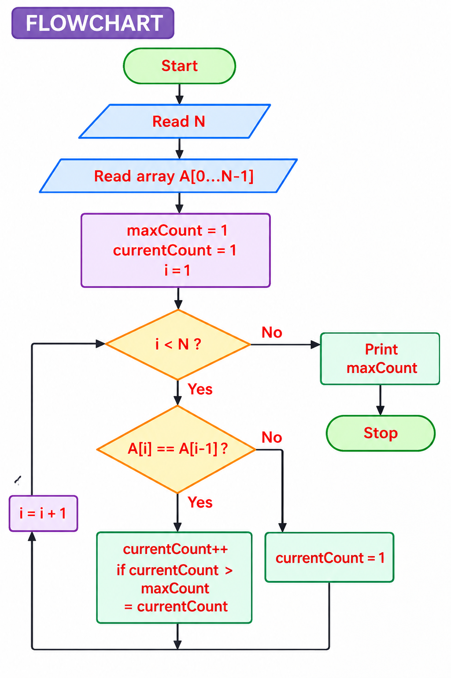

Aim
To design a notification system that sends Email, SMS, or App alerts using a common send() method based on the selected notification type.

Introduction
A notification system is used to send messages to users through different communication channels such as Email, SMS, or Mobile App notifications. In Object-Oriented Programming (OOP), this can be implemented using an interface named Notification that contains a common method called send(). Different classes such as Email, SMS, and App implement this interface and provide their own version of the send() method. This demonstrates polymorphism, where the same method behaves differently depending on the object.

Pseudocode
START

Display:
1. Email
2. SMS
3. App Notification

Read choice

IF choice = 1
Display "Email Notification Sent"
ELSE IF choice = 2
Display "SMS Notification Sent"
ELSE IF choice = 3
Display "App Notification Sent"
ELSE
Display "Invalid Choice"
END IF

STOP

Flowchart
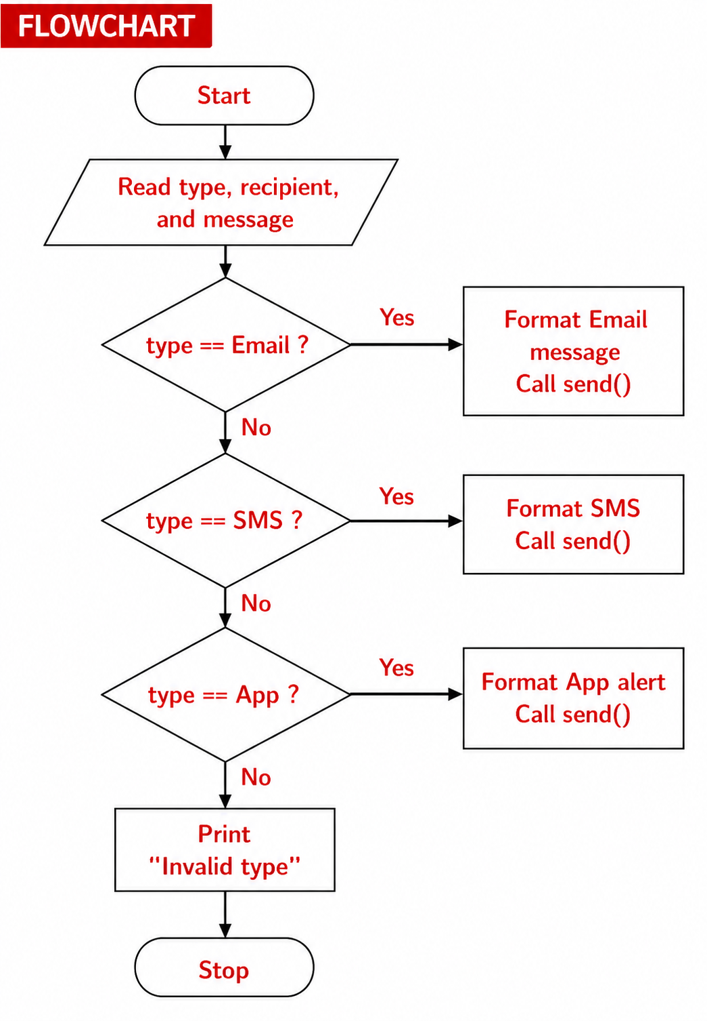

C Program
#include <stdio.h>

int main() {
int choice;

printf("Notification Types\n");
printf("1. Email\n");
printf("2. SMS\n");
printf("3. App Notification\n");
printf("Enter your choice: ");
scanf("%d", &choice);

switch(choice) {
case 1:
printf("Email Notification Sent");
break;
case 2:
printf("SMS Notification Sent");
break;
case 3:
printf("App Notification Sent");
break;
default:
printf("Invalid Choice");
}

return 0;
}
Note: If your lab specifically asks for "interface Notification with a send() method", it is actually a Java OOP concept, not C. The above C program demonstrates the same logic using a switch statement.

